Marine Infrared Communication Repeater with Optical Propagation

Senior Project 2021-2022



Team Members

Ian Green

Natalia Cedeño

Project Advisor

Hossein Asghari, Ph.D.

Department of Electrical and Computer Engineering

Seaver College of Science and Engineering

Loyola Marymount University

Los Angeles, CA

# Abstract

Free space communication systems have enjoyed increased attention due to their high transmission speed, high throughput, and infrastructure-free applications. However, these systems are generally either expensive or static devices. An affordable, dynamic system is required for the creation of ad-hoc networks and to widen adoption of the system. An affordable dynamic system was designed using commercial off-the-shelf products and widely accepted standards, allowing for hobbyist and personal use. The components were tested and operation of greater than 900Mbps was confirmed for the system operating with a fiber optic cable as a transmission medium. This system was designed to operate in near-infrared and was chosen to be eye safe for wide adoption. A galvanometer scanning system was used to create a unidirectional aiming system, allowing one endpoint to move while continuing communication. Free space communication was confirmed to work; however, final testing was unable to be completed by the project deadline.

# Table of Contents

Abstract 2

Table of Contents 3

Introduction 5

Project Objective 5

Background Information 5

Customer Requirements 6

Proposed Solution 6

Technical Requirements 6

System Description 7

Solution Trades 9

Standards and Constraints 10

Design Impact 10

Electrical Design 11

Overall Project Description 11

Schematics 11

Major Tasks 12

Bill of Material 12

Materials & Cost Estimate 12

Testing Results 13

Working Prototype 13

Test Results 14

Discussion of results 16

Ethics Considerations 16

Contribution to ABET program & LMU Mission and Values 16

ABET Program 16

LMU Mission and Values 17

Final Product Demonstration 17

Conclusion 18

References 19

Appendices 20

Appendix A: Detailed Schedule 20

Appendix B: Teammate Roles and Responsibilities 20

Appendix C: Test Plan 21

Purpose 21

Objectives 21

Procedure 21

Test Specimen 22

Expected Results 23

Appendix D: GitHub Links 24

# Introduction

Data has become increasingly important in a variety of defense applications due to its ability to operate in radio frequency (RF) denied environments. Free space optical communication (FSOC) systems offer high-speed transmission without expensive infrastructure. However, FSOC systems are limited by their excessive cost and inability to dynamically follow targets. High-performance systems can cost hundreds of thousands. Koruza, another cheap static system using comparable items as this design costs over $2000. [1] They are therefore limited to large bases and some slow-moving ships. A cheap, dynamic system would expand utility to smaller units and allow for the sharing of data with more components. In civilian applications, this system can help in disaster relief and in rural communities by offering a high-quality communication system without expensive infrastructure.

Cheaper FSOC systems exist but are limited to hobbyist applications. A scientific testbed is required to advance the field of low-cost dynamic systems. Moreover, no open-source affordable dynamic systems currently exist. Creating such a system would allow for more researchers to enter the field by lowering the cost of research.

# Project Objective

## Background Information

The US Department of Navy (DoN) requires high-bandwidth secure communication in RF denied environments. [2] [3] DoN surface vessels collect data that must be immediately shared fleetwide. For example, the Cooperative Engagement Capability and AEGIS systems of the DoN send enormous amounts of data between surface vessels. RF communication suffers from issues that FSOC a better option than traditional radio communication. First, RF communication suffers from high side lobe, sending signals in undesired directions. This undesired radiation allows for other vessels to receive the signal, including enemy ships. With the increasing importance of data in modern warfare, denial of enemy reception of data is paramount. Second, RF communication requires larger bandwidths to match the transmission rate of FSO systems. Larger bandwidths introduce issues of interference as RF bands become increasingly occupied by commercial interests. Third, the RF space has become contested through electronic warfare. Electronic attack systems are being investigated by multiple nations with the intention of disrupting RF systems. Making systems resilient to electronic attacks is vital to national security. Fourth, enemy vessels can track ships emitting RF through electronic surveillance systems. FSO systems operate in line of sight and emit primarily in a single direction, reducing the ability of enemy ships to track through surveillance systems.

However, despite these advantages, FSO systems suffer from the limitation of line-of-sight communication. Over the horizon communication is sometimes necessary for certain fleet configurations. Space-based FSO relays are available; however, space-based systems face interference from weather phenomena like clouds. Communication systems in military applications must be resilient to weather. Space-based communication faces additional difficulty as orbits might not always line up well, increasing project costs significantly as more satellites are required for relays.

Therefore, UAVs offer the ability to relay optical communication in areas where space-based relays are unavailable. They can be weather resilient and integrate well into the existing Navy infrastructure. The Navy has extensive air operation infrastructure in its aircraft carrier fleets, and most fleets have the capability to launch small fixed-wing aircraft. The US Airforce and US Navy both operate extensive UAV fleets that can be easily transitioned to data relays without significant interruption to their primary missions.

This project aims to create a prototype for an affordable dynamic FSO system capable of linking two moving targets. This dynamic link would create the backbone of future ad-hoc networks by linking pairs of nodes in the network.

## Customer Requirements

1. High Bitrate: The system requires 1Gbps communication speed
2. Low-Sidelobe: The system must have a low sidelobe
3. Over the Horizon Communication: The Navy requires over-the-horizon communication
4. Weather Resilient: The system must continue operating normally in inclement weather
5. Continuous Connection: The Navy requires continuous connections with low bit errors
6. Duplex Communication: The Navy must share information between two ships and their sensors bidirectionally.

# Proposed Solution

## Technical Requirements

Our system will have:

1. Software drivers that can operate at 1 Gbps
2. Operating frequency in the infrared range (780 nm – 1 mm) in the eye-safe power range
3. Transmit/receive speed of 1 Gbps of data
4. A tracking device capable of tracking a device at 100m with tangential velocity up to 92m/s within 20mm
5. System to adjust tracking based on live data to account for variable distance and speed of the receiver
6. Two-way simultaneous communication
7. Costs less than $500 to build

Figure 1 summarizes the technical requirements in relation to the customer requirements.

Figure 1: House of Quality

## System Description

The system consists of a static free space optical communication system and a scanning system. The static system has a small form-factor pluggable (SFP) electro-optical transceiver connected to a compatible media converter. The electrical output from this media converter is an RJ45 port, commonly referred to as ethernet. This output can be connected to the desired platform, including personal laptops. To focus the optical output of the SFP transceiver, a mirror of focal length 10 cm is used. This static system has a maximum throughput of 1 Gbps.

The scanning system is composed of a control subsystem and a two-mirror scanner. The control subsystem has an aiming visible laser and a camera to find other transmitters. A Raspberry Pi using Python 3.7 will use the data from the camera to aim the scanner. The scanner has two motors controlling two mirrors which will redirect both the aiming laser and the signal. Figure 2 shows a similar system, Koruza, on which the design was based. Figure 3 shows the modified final hardware design, based on Koruza. Figure 4 shows the final software architecture, the novel solution to tracking a receiver. It uses three threads to decrease delay between updates sent to the motor.

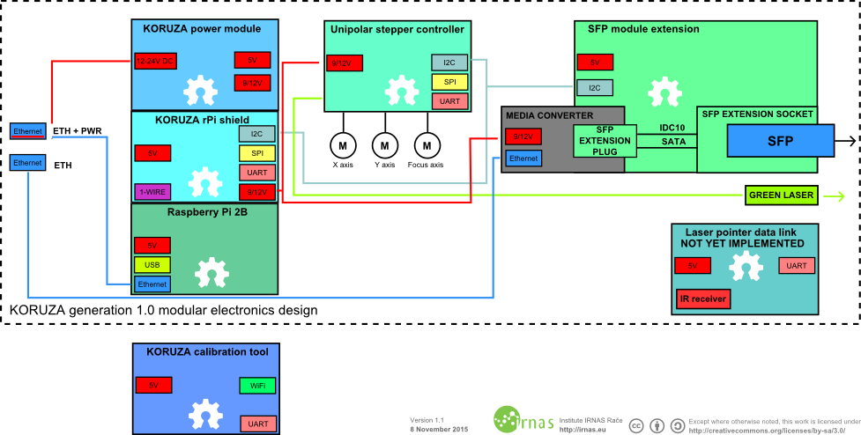

Figure 2: Koruza System Diagram [4]

Figure 3: Hardware System Diagram

Figure 4: Software System Diagram

Figure 5 describes the work breakdown structure of this project.

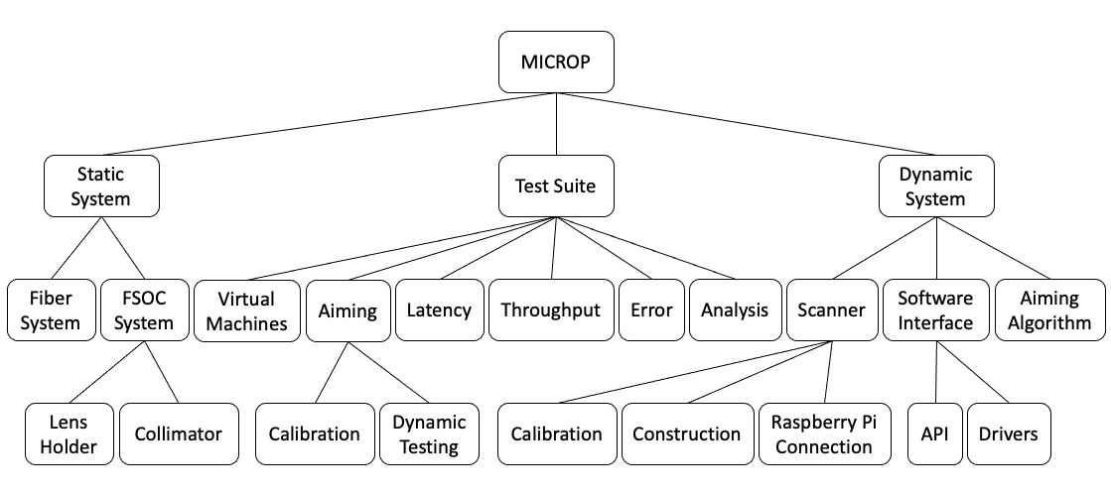

Figure 5: Work Breakdown Structure

## Solution Trades

In implementing this design, some trades were required to stay within budget and time constraints. The bitrate was lowered from an achievable 10Gbps to 1Gbps due to the budgetary constraints as 10Gbps hardware is more expensive. For the same reason, a scanner was chosen with a lower than ideal update rate to reduce costs. Additionally, the scanner was designed for visible light as visible light scanners are cheaper and more readily available. Budget constraints also limited the controlling hardware to a Raspberry Pi 3B+, which limited the software to 32bits.

Time constraints also limited substantial portions of the project. Due to a long delay in the delivery of the scanning system, work on the dynamic system did not begin until March 2022, well after the planned December start date. Therefore, the goal of two dynamic endpoints was scrapped in favor of a single moving endpoint to be used to prove the concept. Moreover, the delay in cable delivery slowed down testing of the free space system, pushing the goal of free space dynamic testing back to the end of the semester.

## Standards and Constraints

The design of this system, outlined in the System Description, was guided by Institute of Electrical and Electronics Engineers (IEEE), International Electrotechnical Commission (IEC), Internet Engineering Task Force (IETF), and Storage Networking Industry Association (SNIA) standards.

As detailed in the System Description, two SFPs are used as electro-optical transceivers. SFPs follow SNIA multi-source agreement INF-8074. [5] The SFPs purchased use the 850nm 1000Base-SX standard for speed and throughput negotiation. The media converters used similarly follow INF-8074 and 1000Base-SX standards for SFPs. Fiber connections between the SFPs for testing use the Lucent Connector (LC) fiber connection standard, following.

The media converters and ethernet cables use RJ45 connectors. RJ45 connectors are standardized in IEEE 802.3. [6] The ethernet cables used are category 8 (CAT8), following IEC 61754-20 and IEEE 802.3. [7] To connect a personal laptop to the ethernet cable, the USB-C interface was used, which is described in standard IEC 62680-1-3. [8] Communication utilized TCP/IP connections as described in IETF RFC-793. [9]

The system was constrained primarily by cost limitations and laboratory equipment. Equipment for wavelengths greater than 1000nm was prohibitively expensive, requiring the design to operate in near-IR at 850nm. A similar design produced on a larger scale would also benefit from the decreased costs associated with economy of scale. Industrial processes can reduce the cost by combining parts and buying in bulk. So, the final cost of this system is not representative of the possible cost if it were produced in large quantities.

## Design Impact

This project has benefits in military, civilian, and research applications. In military applications, there is a need for dispersed ad-hoc networks in naval and ground communication systems. In civilian applications, it can be used for disaster relief and connecting hard to reach communities. As a low-cost platform, it would benefit free space optical research by lowering the barrier for entry for a potential researcher.

In military applications, there is a persistent need for high-throughput, stable, and dynamic communication systems. Networks must span large areas with a variety of obstacles and endpoints, which requires a system that is able to adapt to changes rapidly. The increasing focus on data as a defense resource requires increased throughput to ensure units are kept updated on developments and intelligence. A cheap and dynamic free space optical communication system allows for a wide breadth of endpoints in the network, interconnecting a larger number of units.

This system also has humanitarian benefits. The use of ad-hoc networks in disaster areas is important to allow for rapid communication in disaster response teams. Current systems are cumbersome and limited by cost. A cheaper and dynamic system would allow for rapid deployment of networks to affected areas and reduce the setup time for humanitarian efforts. The system could be coupled with other response systems, including imagery systems, on drones to provide a rapid and complete picture of the area to assist in humanitarian efforts.

For hard to reach and small communities, infrastructure is hard to develop due to the difficulty of constructing the infrastructure, the challenge of maintaining infrastructure, and the low profit margin for small communities. Therefore, many rural and small communities have poor infrastructure, including communication systems. A free space system allows for these communities to improve communication without requiring infrastructure. A low-cost system could be used by smaller communities, lowering the barrier to entry.

Free space optical research is expensive, limiting research to well-funded labs and universities. Lowering the cost of a simple system allows for research to be conducted by a larger range of parties, including amateurs. Widening the pool of potential researchers advances the field as a whole and will produce better communication systems, lending itself to the benefits discussed above.

# Electrical Design

## Overall Project Description

The system is split into three sections. The first is a static fiber optic system operating at 1Gbps. LC fibers are used to connect the two endpoints. The second is a static FSOC system, able to communicate without fiber. The third is a dynamic FSOC system that can move both endpoints and maintain communication. The static fiber system was constructed in the Fall 2021 semester.

The project is aimed at military applications but has a wide range of applications outside of the military. It can be used in disaster relief and in reaching rural communities without expensive infrastructure. By reducing cost and aiming the system dynamically, it is far less limited than current systems, widening the utility of the product.

## Schematics

Figure 3 shows the physical block diagram of the system. Figure 4 shows the software architecture of the system. Figure 6 shows the circuit diagram for the driver. The circuit uses a digital-to-analog converter (DAC) to generate analog current, which the first operational amplifier (OpAmp) converts to voltage. The second unity-gain OpAmp acts as a buffer, and the third negative gain OpAmp produces the positive signal for the required bipolar signal.

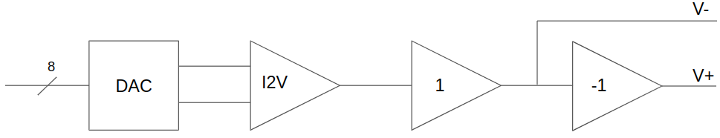

Figure 6: Circuit Diagram of Driver

## Major Tasks

The project is split into three stages. Stage one is the construction of a static fiber optic communication system using the SFPs connected via LC fiber. This stage was completed in Fall of 2021. Stage two is a static free space optical system using the same hardware by removing the LC fiber. Additional collimators are added. The third stage is a dynamic free space optical system using scanners to aim the laser. The detailed schedule is found in Appendix A.

Testing must be performed at each stage of construction to verify the continued operation of the system. A tracking algorithm must be created using the visible laser aiming system and ensuring continual connection.

## Bill of Material

Table 1 shows the bill of materials for the project. The project was over budget due to issues with the original scanning motors, requiring a new scanner to be purchased.

Table 1: Bill of Materials

|  |  |  |  |
| --- | --- | --- | --- |
| Supplies | Quantity | Cost ($) (ea.) | Cost ($) (total) |
| Raspberry Pi 2B | 2 | $0.00 | $0.00 |
| 850 nm Multimode Fiber SFP | 2 | $12.00 | $26.01 |
| RJ45 to USB-C Converter | 2 | $13.59 | $29.46 |
| CAT-8 Ethernet Cable | 2 | $2.99 | $6.48 |
| 50 mm Diameter, 100 mm Focal Length Plano-Convex Lens | 2 | $8.09 | $17.54 |
| Galvanometer Scanner | 2 | $85.03 | $186.22 |
| Media Converter | 2 | $19.88 | $42.54 |
| Raspberry Pi NoIR Camera | 2 | $12.49 | $26.72 |
| Aiming Laser | 2 | $17.99 | $39.00 |
| Galvanometer Scanner (new) | 1 | $135.99 | $135.99 |
| LC/UPC to FC/UPC | 1 | $5.00 | $5.00 |
| LC/UPC to FC/APC | 2 | $20.00 | $40.00 |
| Total | $554.96 | | |

## 

## Materials & Cost Estimate

Table 2 describes the materials used for this project along with their respective cost breakdown. The cost represents the total price including tax and shipping if applicable.

Table 2: Cost Estimate

|  |  |  |
| --- | --- | --- |
| Item | Quantity | Cost |
| Raspberry Pi 2B | 2 | $0.00 |
| Raspberry Pi NoIR Camera | 2 | $26.72 |
| 850 nm Multimode Fiber SFP | 2 | $26.01 |
| 50 mm Diameter, 100 mm Focal Length Plano-Convex Lens | 2 | $17.54 |
| Galvanometer Scanner | 2 | $186.22 |
| Media Converter | 2 | $42.54 |
| Visible Light Aiming Laser | 2 | $39.00 |
| RJ45 to USB-C Converter | 2 | $29.46 |
| CAT-8 Ethernet Cable | 2 | $6.48 |
| 50/125 Multimode LC-LC Duplex Fiber Patch Cable | 2 | $18.46 |
| Total | $392.43 | |

# Testing Results

## Working Prototype

A proof-of-concept prototype of the system was constructed. A picture of the system is shown in Figure 7.

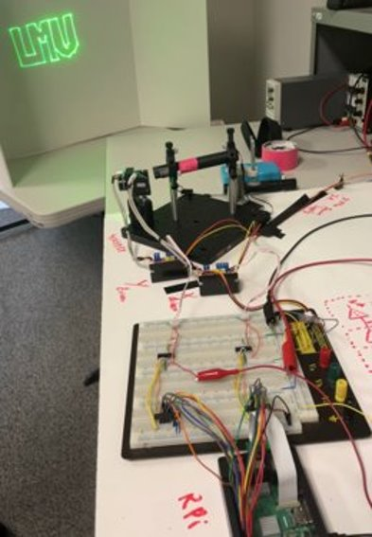

Figure 7: Final Working Prototype

## Test Results

To verify correct operation of each component, system throughput, latency, and packet loss were tested for a variety of experimental setups. These setups were limited to fiber and control experiments; free space has not been tested. Plans to test the free space system are found in Appendix C and will be carried out in the final week of the Spring semester. A hardware-in-the-loop setup was constructed by connecting the SFPs together through an LC cable and connecting the media converters to personal computers. An ethernet cable only test was performed where both endpoints were directly connected via ethernet cable to create a control. Further tests were done with the two endpoints sharing one port on a laptop, and the final setup had both endpoints sharing the same network adapter. To simplify these experiments and reduce errors from varying hardware, one laptop was used, and the endpoints were separated using virtualization.

The results of the throughput tests are shown in Table 3 and Figure 8. Table 4 and Figure 9 show the latency test results. Table 5 shows the numbers of packet loss per byte of transmitted data for each setup as an approximation of error.

Table 3: Throughput Results

|  |  |  |  |
| --- | --- | --- | --- |
| Testing Setup | Bidirectional Throughput  (Mbps) | Parallel Bidirectional Throughput  (Mbps) | Unidirectional Throughput  (Mbps) |
| Hardware-in-the-loop fiber | 941 ± 24 | 899 ± 71 | 941 ± 22 |
| Ethernet Cable Only | 925 ± 125 | 863 ± 112 | 941 ± 24 |
| Shared port | 2894 ± 196 | 1633 ± 260 | 2913 ± 196 |
| Shared network adapter | 2719 ± 334 | 1578 ± 269 | 2714 ± 427 |

Table 4: Latency Results

|  |  |
| --- | --- |
| Testing Setup | Unidirectional Latency (ms) |
| Hardware-in-the-loop fiber | 1.32 ± 0.32 |
| Ethernet Cable Only | 1.32 ± 0.3 |
| Shared port | 1.06 ± 0.22 |
| Shared network adapter | 1.1 ± 0.26 |

Table 5: Error Results

|  |  |  |  |
| --- | --- | --- | --- |
| Testing Setup | Bidirectional Error | Parallel Bidirectional Error | Unidirectional Error |
| Hardware-in-the-loop fiber | 4.24E-08 | 2.18E-07 | 6.99E-08 |
| Ethernet Cable Only | 1.08E-07 | 2.46E-07 | 7.26E-08 |
| Shared port | 5.39E-06 | 2.78E-06 | 5.34E-06 |
| Shared network adapter | 5.53E-06 | 2.55E-06 | 5.49E-06 |

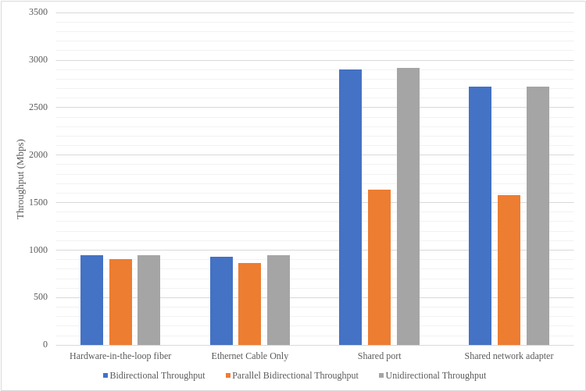

Figure 8: Throughput Results

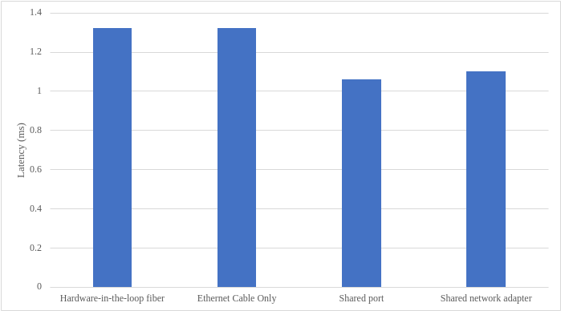

Figure 9: Latency Results

## Discussion of results

Our tests demonstrate that the fiber testbed is correctly operating, and the free-space system does not introduce large attenuation. However, full free-space tests remain to be completed, and the integration tests require additional work and analysis. The static portion of the test plan in Appendix C.Roles and responsibilities were evenly split between **t**eam members. Natalia was primarily tasked with hardware while Ian was primarily tasked with software. Details on the assignment of each task are found in Appendix B.

# Ethics Considerations

It is unethical to produce a device which would harm its users. Therefore, this design was constructed to be eye safe and electrically safe. The infrared laser was chosen over a visible light laser to ensure eye safety. A weaker laser was chosen despite limiting the abilities of FSOC systems because weaker lasers are less likely to be harmful. In addition, commercial off-the-shelf pluggable systems were chosen to reduce the chance of harm from electrical wires or improper wiring. This product was tested against safety standards. The laser power was found to be less than a harmful level. Tests were performed in closed rooms to limit the possibility of accidental harm to bystanders.

By reducing the need for infrastructure and the overall cost of the system, the public welfare benefits. It reduces the environmental harm of the system as infrastructure destroys ecosystems and interrupts animal habitats. The reduced cost and lower installation cost further benefit those in hard-to-reach communities and rural areas by opening their communities to communication systems that had previously been denied to them. This expansion of systems increases the equity of access to high-speed internet and other communication systems.

# Contribution to ABET program & LMU Mission and Values

## ABET Program

This project addresses all seven ABET student outcomes. [10]

The project addresses outcome one, “an ability to identify, formulate, and solve complex engineering problems by applying principles of engineering, science, and mathematics.” The project poses a nontrivial engineering problem that has not been achieved before. Free space optical communication systems are expensive and static, so achieving a dynamic and cheap system is unique and difficult.

The project addresses outcome two, “an ability to apply engineering design to produce solutions that meet specified needs with consideration of public health, safety, and welfare, as well as global, cultural, social, environmental, and economic factors.” This project was designed for the safety of users by using eye-safe optical communication and standards that can interface with personal laptops, allowing a non-technical user to use the system. Through humanitarian and military applications, this system could be utilized to help public welfare.

The project addresses outcome three, “an ability to communicate effectively with a range of audiences.” Presentations were given for audiences of nontechnical background, including those of different majors. Team members were expected and able to communicate effectively to both technical and nontechnical audiences.

The project addresses outcome four, “an ability to recognize ethical and professional responsibilities in engineering situations and make informed judgments, which must consider the impact of engineering solutions in global, economic, environmental, and societal contexts.” Safety and environmental factors were considered at every step of the design process, and only eye safe products were purchased.

The project addresses outcome five, “an ability to function effectively on a team whose members together provide leadership, create a collaborative and inclusive environment, establish goals, plan tasks, and meet objectives.” As part of the project, team members met weekly with advisors and established weekly goals and plans to ensure completion of the objectives. Agreed objectives were consistently met.

The project addresses outcome six, “an ability to develop and conduct appropriate experimentation, analyze and interpret data, and use engineering judgment to draw conclusions.” Each component of the system was tested, and the data was aggregated and processed. From these test results, conclusions were drawn and presented.

The project address outcome seven, “an ability to acquire and apply new knowledge as needed, using appropriate learning strategies.” A substantial portion of the assignment was the research and design process, which addressed this outcome.

## LMU Mission and Values

LMU’s mission statement states, “by intention and philosophy, we invite men and women diverse in talents, interests, and cultural backgrounds to enrich our educational community and advance our mission: The encouragement of learning. The education of the whole person. The service of faith and the promotion of justice.” [11]

The project clearly aligns with the encouragement of learning as a research and design project. Team members were expected to learn about FSOC systems and participate in the design of such a system. In addition, team members were expected to consider the societal ramifications of the project, which required education beyond the scope of engineering. This led to the education of the whole person as team members learned about social justice issues and the role of communication in society. Towards the promotion of justice, team members ensured the project would have benefits for disadvantaged communities. While the main customer is the DoN, the project was tailored to ensure benefits for other communities. These benefits are discussed in more detail in the Design Impact section.

## Final Product Demonstration

At the end of the Spring 2022 semester, a dynamic system using SFP will be demonstrated. It will be within a 500 USD budget and will be able to communicate as both endpoints move. Although this system will not be ready for use in military or civilian applications, it will serve as an important proof-of-concept and test system for development of the software and hardware. A test plan is in Appendix C to demonstrate that customer and technical requirements are met by the system.

The system will consist of two transceivers with aiming capabilities. Each will be mounted on a movable platform. Their bitrate will be tested along with their ability to maintain a link as both endpoints are moved randomly.

# Conclusion

Affordable dynamic FSOC systems have a wide range of applications. The designed system would allow for high-speed communication without infrastructure between moving endpoints. The hardware tested can reach nearly 1Gbps. The limit of the system appears to be the test suite used, primarily the USBC to ethernet adapter. Further testing of the static free space system is required. Moreover, the scanner must be constructed and implemented to allow the system to dynamically track during communication. A tracking algorithm must be planned and coded.

# References

|  |  |
| --- | --- |
| [1] | "Order," Koruza, 2021. [Online]. Available: http://www.koruza.net/order/. [Accessed 2 December 2021]. |
| [2] | "Navy eyes free-space laser communications to transmit wireless data to users more than six miles away," 25 June 2021. [Online]. Available: https://www.militaryaerospace.com/communications/article/14205806/laser-communications-wireless. [Accessed 15 September 2021]. |
| [3] | S. Jontz, "U.S. Navy Runs Interference on Signals Conflict," Armed Forces Communications Association, 1 February 2017. [Online]. Available: https://www.afcea.org/content/Article-us-navy-runs-interference-signals-conflict. [Accessed 15 September 2021]. |
| [4] | "About Koruza 1.0," 2017. [Online]. Available: http://scientific.koruza.net/about-koruza-1.0/. [Accessed 3 December 2021]. |
| [5] | "INF-8074i Rev 1.0," SFF Committee, 2001. |
| [6] | "IEEE 802.3-2018 - Standard for Ethernet," Institute of Electrical and Electronics Engineers, 2018. |
| [7] | "IEC 61754-20 Edition 2," International Electrotechnical Commision, 2012. |
| [8] | "IEC 62680-1-3:2021," International Electrotechnical Commission, 2021. |
| [9] | "IETF RFC-793 - Transmission Control Protocol," Information Sciences Institute, 1981. |
| [10] | "Criteria for Accrediting Engineering Programs, 2021 – 2022 | ABET," 2021. [Online]. Available: https://www.abet.org/accreditation/accreditation-criteria/criteria-for-accrediting-engineering-programs-2021-2022/. [Accessed 3 December 2021]. |
| [11] | "Our Mission - Loyola Marymount University," 2021. [Online]. Available: https://www.lmu.edu/academics/provost/ourmission/. [Accessed 3 December 2021]. |

# Appendices

## Appendix A: Detailed Schedule

Table 6 describes the detailed schedule of the project with the major tasks detailed into subtasks.

Table 6: Gantt Chart

|  |  |  |  |
| --- | --- | --- | --- |
| Task | Assigned  To | Start | End |
| Research and Development | | | |
| Static Design | Both | 9/12/21 | 9/15/21 |
| Order parts | Ian | 9/15/21 | 10/1/21 |
| Scanner Design | Both | 12/6/21 | 12/13/21 |
| Tracking Algorithm | Both | 2/14/22 | 2/19/22 |
| FANET Design | Both | 5/28/22 | 5/30/22 |
| Static Design | | | |
| Construct Transmitter | Ian | 10/25/21 | 12/6/21 |
| Construct Receiver | Natalia | 10/25/21 | 12/6/21 |
| Lab Condition Testing | Both | 12/6/21 | 12/13/21 |
| Single Motion Design | | | |
| Scanner Parts Ordering | Natalia | 12/13/21 | 12/18/21 |
| Construct Scanner | Both | 1/10/22 | 1/17/22 |
| Test Scanner | Natalia | 1/17/22 | 1/24/22 |
| Scanner Tracking Implementation | Ian | 1/17/22 | 1/31/22 |
| One way tracking testing | Both | 1/31/22 | 2/10/22 |
| Dual Motion Design | | | |
| Mount receiver on drone | Natalia | 2/10/22 | 2/17/22 |
| Test drone receiver while moving | Natalia | 2/17/22 | 3/10/22 |
| Mount transmitter on drone | Ian | 2/10/22 | 2/17/22 |
| Test drone transmitter while moving | Ian | 2/17/22 | 3/10/22 |
| Test drone-to-drone communication | Both | 3/10/22 | 4/14/22 |
| Demonstrate FANET feasibility | Both | 4/14/22 | 4/21/22 |

## Appendix B: Teammate Roles and Responsibilities

Roles and responsibilities were evenly split between team members. Natalia was primarily tasked with hardware while Ian was primarily tasked with software. Details on the assignment for each task are found in Appendix A.

## Appendix C: Test Plan

### Purpose

Prototypes for static and dynamic free-space optical communication (FSOC) systems will be created. The static system will primarily satisfy the high bitrate requirement and the dynamic system will primarily satisfy the over the horizon requirement. All other requirements will be satisfied in both systems.

### Objectives

To determine the success of each system, the latency and throughput will be measured during various trials. The tests will be performed through two virtual machines, running Ubuntu 20.04. Various cores will be carried out for the throughput tests and various throughput setups will be used to help identify the root cause of bottlenecks.

The latency and throughput tests include unidirectional and bidirectional in both the control and experimental setups. The ping command will be used to perform latency tests, while Ipeff3 will be used to perform throughput tests. Python 3.8 will be used to analyze the data gathered during experiments.

### Procedure

Static System Testing:

1. Connect ethernet to USB-C converters to USB-C ports on laptop.
2. Create two virtual machines registered to each port.
3. Create shared folders on each virtual machine to store data from test trials.
4. As a control, directly connect an ethernet CAT-8 cable to each port.
5. From virtual machine 1 (VM1), ping virtual machine 2 (VM2) to run several latency tests on the control system and store data to shared folder.
6. Run bidirectional latency tests by storing output of the ping command on control system and store data to shared folder.
7. Repeat control latency tests, pinging VM1 from VM2, and store onto shared folder.
8. Run throughput tests on one core using Iperf from VM1 to VM2 and store results to shared folder.
9. Repeat one core throughput tests, going from VM2 to VM1.
10. Run one core bidirectional throughput tests on control system.
11. Run bidirectional tests on both VM1 and VM2 simultaneously to increase traffic congestion.
12. Repeat all throughput tests with three cores and store data on shared folders.
13. Disconnect one end of the ethernet cable and connect it to one of the media converters.
14. Repeat this setup with the other port.
15. Connect the SFPs to their respective ports on the media converters.
16. For the experimental fiber setup, directly connect an LC duplex fiber between the two SFPs and power the media converters.
17. Repeat steps 5 through 12 for the fiber experimental setup.
18. Disconnect LC duplex fiber from one SFP and connect the second LC fiber to SFP.
19. Tape open ends of LC fibers onto their respective media converter
20. Set lenses in lens holders and place each lens 10 cm away from the media converter.
21. Adjust set up of beams for collimation and align transmitting beams to receivers. Note the size of each beam and check for fiber light on media converters to ensure data is transmitting and receiving properly through the FSOC system.
22. Repeat steps 5 through 12 for the static FSOC system

Dynamic System Testing:

1. The setup will be placed in the FSOC configuration as detailed in steps 18 through 21 with a scanner system placed immediately after the lens of each endpoint.
2. The scanner will be calibrated by placing it at the distance from the lens at which the beam divergence is minimum.
3. The ability to connect with the scanner reflecting the beam will be confirmed.
4. The power loss of the scanner will be found by comparing the relative strength at an equal distance of the setup with the scanner and without the scanner.
5. The throughput and latency tests detailed in steps 5 through 12 be repeated for the dynamic system.
6. The dynamic system will be placed into a container to allow for easier movement
7. The system throughput and latency will be tested as detailed in steps 5 through 8 again inside the container. The values from this test will be used as the maximum rated throughput and latency of the system.
8. Both endpoints of the system will be connected to a different Raspberry Pi 2B+ (RPi).
9. The system will be tested again as detailed in steps 5 through 12 with both the scanner and RPi in use.
10. One dynamic FSOC and corresponding RPi will be placed on a movable mount.
11. The endpoint mounted on a movable mount will be moved in a predetermined random path at increasing velocities. The maximum speed at which the system can maintain connectivity will be measured.
12. Both endpoints will be placed on a movable mount with its corresponding RPi.
13. The test from step 9 will be repeated with both endpoints moving.
14. The final dynamic system will be tested as detailed in steps 5 through 12.

### Test Specimen

The test will be performed on 5 separate setups. The static fiber system will be used to benchmark the maximum possible throughput and latency of the system’s components and identify bottlenecks. The static free space system without the scanner will be used to find issues introduced into the system from free space communication. The static free space system with the scanner will be used to test the maximum realizable throughput and latency of the final system. This setup will be repeated using the RPi as a test system to find the effects of the RPi on the throughput and latency. The dynamic free space system will be used to test the ability of the system to track moving endpoints and to determine the maximum relative velocity of the two endpoints while maintaining connectivity.

### Expected Results

The throughput results from the static system are expected to be approximately 1Gbps and about 300Mbps for the dynamic system. The difference in expected throughput is due to the use of the RPi, which has significantly lower throughput than larger, more powerful personal computers. The latency of the dynamic system is expected to be less than that of the static system due in part to the decreased processing power of the RPi and the increased packet loss from lag time in tracking the device.

# Appendix D: GitHub Links

Project GitHub Account: <https://github.com/LMU-Capstone>

Project GitHub Repository: <https://github.com/LMU-Capstone/microp>

Ian Green’s GitHub: <https://github.com/igreen1>

Natalia Cedeno’s GitHub: <https://github.com/nataliacedeno>